=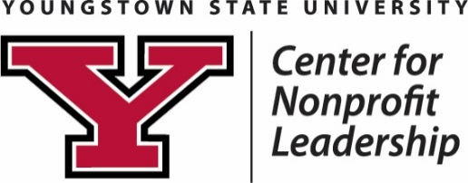
Pay It Forward: Student Philanthropy Initiative
2026 Grant Application

Contact Information: | Name of Organization:  Name of Program/Project:  Address:  City, State Zip:  Website:  Primary Contact Person Name:  Title:  Phone:  Email:
Funding Priorities: | What issue does your program/project address?  Childhood poverty Food deserts  Transportation Workforce development

Organization: In one to two paragraphs, please describe your organization.

Summary: In one to two paragraphs, please describe the program/project funding is requested.

Strategy: Describe how your organization will execute this program/project. What is the timeline
for completion?

Outcomes: Briefly discuss the outcomes of your program/project. What are the measurable results of your program/project? What impact will be made? How does this program/project create social change in the Mahoning Valley?

Diversity: Briefly discuss diversity within your organization.

Budget/Project Costs:  Total amount requested must not exceed $2,000. | Please specify all costs associated with this program/project.
  Please list expenses here: | Requested from Pay It Forward (YSU): | Other Funds Available: | Total:
  TOTAL:

Tax Exempt Status:

YES – my organization is a registered 501(c)(3) tax-exempt organization.

Federal Employer Identification Number:

Copy of IRS Letter of Determination is attached.

NO – my organization is not yet registered as a 501(c)(3) tax exempt organization, but our

fiscal sponsor is: __________________________________.

Proof of relationship attached.

Federal Employer Identification Number:

Please send completed applications to: LJDewberry@ysu.edu.

Additional Information:
- All applications must be received by noon on Friday, March 6, 2026.
- Finalists for funding must be available to host YSU students for a site visit in March or April 2026.

