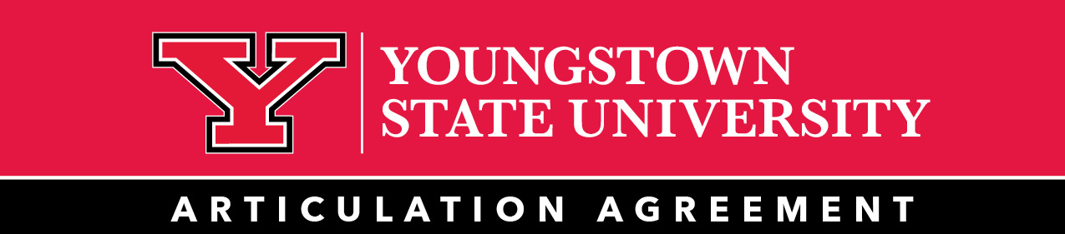

Degree Plan/Pathway Catalog Year 2024-2025

Cuyahoga Community College and Youngstown State University

AAS in Radiology to Bachelor of Science in

Applied Science in Allied Health

Suggested Transfer Pathway at Tri-C (2+2)
First Semester
Course Code and Title | Credit Hours
BIO 1221 ANATOMY AND PHYSIOLOGY FOR DIAGNOSTIC AND MEDICAL IMAGING | 4
DMS 1351 PATIENT CARE SKILLS | 1
MA 1020 MEDIAL TERMINOLOGY 1 | 3
MATH 1410 ELEMENTARY PROBABILITY AND STATISTICS 1 | 3
ENG 1010/101H COLLEGE COMPOSITION 1/HONORS | 3
PSY 1010/101H GENERAL PSYCHOLOGY/HONORS | 3

Second Semester
Course Code and Title | Credit Hours
BIO 2200 RADIOBIOLOGY | 2
RADT 1300 FUNDAMENTALS OF RADIOGRAPHY | 4
RADT 1400 RADIOGRAPHIC POSITIONING | 3

Third Semester
Course Code and Title | Credit Hours
RADT 1911 or RADT 191S or RADT 191A AND 191B CLINICAL RADIOGRAPHY 1 (OPTION A) or CLINICAL RADIOGRAPHY 1 (OPTION B) or CLINICAL RADIOGRAPHY 1 (OPTION C) | 5-7

Fourth Semester
Course Code and Title | Credit Hours
RADT 1351 IMAGE ACQUISITION AND EVALUATION | 3
RADT 1410 INTERMEDIATE RADIOGRAPHIC POSITONING | 3
RADT 2401 IMAGING SYSTEMS | 2
ENG 1020/102H COLLEGE COMPOSITION 2/HONORS | 3

Fifth Semester
RADT 2911 or RADT 291S or RADT 291A and 291B CLINICAL RADIOGRAPHY 2 (OPTION A) or CLINICAL RADIOGRAPHY 2 (OPTION B) or CLINICAL RADIOGRAPHY 2 (OPTION C) | 7

Sixth Semester
Course Code and Title | Credit Hours
PHYS 2250 RADIOGRAPHIC PHYSICS AND QUALITY CONTROL | 4
RADT 2350 RADIOGRAPHIC PATHOLOGY | 3
RADT 2362 INTERVENTIONAL RADIOLOGY AND PHARMACOLOGY | 1

Seventh Semester
Course Code and Title | Credit Hours
RADT 2921 or RADT 292S or RADT 2921 CLINICAL RADIOGRAPHY 3 (OPTION A) or CLINICAL RADIOGRAPHY 3 (OPTION B) or CLINICAL RADIOGRAPHY 3 | 5-7

Additional Information
- Course sequence may change based on the individual needs of the student and schedule type required.
- New college students may be required during their first semester to participate in GEN 1070, First Year Success Seminar, a one credit hour course.
- See a Tri-C Counselor for details
- BIO 2331 Anatomy and Physiology 1 and BIO 2341 Anatomy and Physiology 2 together will be accepted in place of BIO 1221 Anatomy and Physiology for Diagnostic Medical Imaging

Suggested Degree Plan at YSU
Eighth Semester
Course Code and Title | Credit Hours
CMST 1545 SPEECH COMMUNICATION | 3
GER ELCT CRSE OT36 APPROVED GENERAL EDUCATION COURSE | 3
AHLT 3704 QUANTITTIVE METHODS IN HEALTH SCIENCES | 3
PHLT 3708 PREVENTATIVE PUBLIC HEALTH CARE | 3
AHLT 3711 HEALTHCARE INFORMATION SYSTEMS | 3

Ninth Semester
Course Code and Title | Credit Hours
AH CRSE OT36 APPROVED ARTS AND HUMANITIES COURSE | 3
GER ELCT CRSE OT36 APPROVED GENERAL EDUCATION ELECTIVE COURSE | 3
AHLT 4806 RESEARCH METHODS | 3
AHLT 4810 MANAGEMENT SKILLS FOR HEALTH PROFESSIONALS | 3
UD CRSE UPPER DIVISION COURSE | 3

Tenth Semester
Course Code and Title | Credit Hours
ELCT CRSE ELECTIVE COURSE | 3
ELCT CRSE ELECTIVE COURSE | 3
AHLT 3740 PATHOLOGY OF INFECTIOUS DISEASE | 3
AHLT 4805 HEALTH EDUCATION | 3
UD CRSE UPPER DIVISION COURSE | 3

Eleventh Semester
Course Code and Title | Credit Hours
AHLT 4820 DIRECTED RESEARCH | 3
AHLT 5807 EPIDEMIOLOGY | 3
AHLT 5840 COMPARATIVE HEALTH SYSTEMS | 3
US CRSE IPPER DIVISION COURSE | 3

Additional Information
- Bachelor of Science in Applied Science Degree Awarded Total Hours: 121
- With the submission of an unencumbered Radiology license, students will receive 10 credit hours of AHLT 37XEC which will be used to replace the upper division elective courses.
- Between 3 and 7 elective credits are needed depending upon what selection of classes are completed at Cuyahoga Community College (i.e. RADT 1911 or 191S or 191A and B)
- See Youngstown State Transfer Guide for course options.
- All courses are offered on a 7-week accelerated schedule. Each semester there will be two 7-week sessions offered. This Transfer Pathway represents one example of how to complete an associate and bachelor degree.
- Students should work closely with advisors at both institutions to discuss options.
- Students should work with an Allied Health advisor to identify a (minor or a second major/etc.). An Allied Health advisor can also assist students with developing a graduation plan for full- or part-time study.
- Taking certain elective courses will allow the student to come in at junior status.
- This program awards maximum credit for an associate degree from Cuyahoga Community College, streamlining completion of a bachelor’s degree from Youngstown State University.

All students must meet or complete:
- All residency requirements 30 credits and 16 upper division for YSU, plus major and minor residency
- Experiential Learning requirement (Ex.: internship, field experience, community service)

