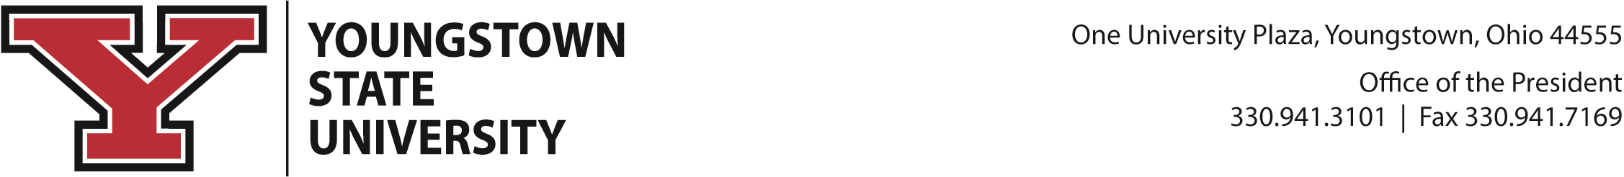

BOARD OF TRUSTEES’ MEETING

Thursday, March 4, 2021
10:00 a.m. https://ysu.edu/board-of-trustees

AGENDA
- Roll Call
- Proof of Notice of Meetings
- Disposition of Minutes
- Report of the President of the University
- Report of the Committees of the Board
- Academic Excellence and Student Success Committee
Faculty Presentation: Dr. Amy Fluker, Department of Humanities and Social Sciences
Student Presentation: Kara Bischoff, Civil Engineering student
Student Presentation: Nursing Department Students
- Resolution to Modify Honorary Degrees and Commencement Speakers Policy, 3356-10-05
- Resolution to Modify Intellectual Property Rights Policy, 3356-10-18
- Resolution to Authorize Conferral of Honorary Degree, Harold Danko
2. Institutional Engagement Committee
a. Resolution to Accept WYSU Memberships
3. Finance and Facilities Committee
a. Resolution to Modify Reduction/Refund of Tuition and Fees Policy, 3356-3-02.1
b. Resolution to Modify University Facilities – Use, Priorities, and Fees Policy, 3356-4-03
c. Resolution to Modify Acquisition of Real Estate Policy, 3356-4-05
d. Resolution to Modify Identity Theft Red Flags Policy, 3356-4-14
e. Resolution to Approve Changes to Student Fees
f. Resolution to Approve Interfund Transfers
g. Report of the Audit Subcommittee, Michael A. Peterson, Chair
h. Report of the Investment Subcommittee, Capri S. Cafaro, Chair
4. University Affairs Committee
a. Resolution to Ratify Personnel Actions – Intercollegiate Athletics
b. Resolution to Modify and Retitle Externally Funded Professional/Administrative Staff Policy, 3356-7-43
c. Resolution to Modify and Retitle Acting/Interim Appointments of University Administrators Policy, 3356-9-10
d. Resolution to Modify and Retitle Public Use of University Grounds for Expressive Activity Policy, 3356-4-21
e. Resolution to Approve the Reclassifications of Personnel:
Joy Polkabla Byers, Associate Vice President for Student Experience
Elaine Ruse, Associate Vice President for Student Enrollment and Business Services
Nicole Kent-Strollo, Dean of Students and Ombudsperson
f. Resolution to Ratify Personnel Actions – Faculty and PA Staff
g. Youngstown State University Board of Trustees Resolution to Extend the Contract of the Provost and Vice President for Academic Affairs Through June 30, 2025
5. Governance Committee
a. Nomination of 2021-2022 Board Officers
b. Nomination of National/Global Trustee, Eric Spiegel

6. Executive Committee
a. Resolution to Approve Fourth Presidential Employment Extension and Third Amendment with Youngstown State University President James P. Tressel
F. Communications, Memorials, and News Updates
G. Unfinished Business
H. New Business
I. Chairperson’s Remarks
J. Dates and Times of Upcoming Regular Meetings of the Board
Tentative Meeting Dates: 10 a.m., Thursday, June 3, 2021
10 a.m., Thursday, September 2, 2021
10 a.m., Thursday, December 2, 2021
K. Adjournment

